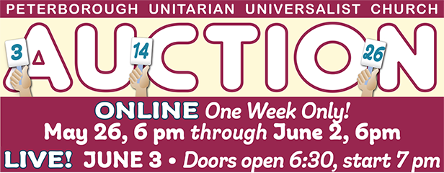
Donation Form: Provide a Service

This form is due by May 19 at the latest.
Name
Address
Phone: Cell or landline
Email
Donation ¹
Location where service will be provided ²
Value
Minimum Bid (generally 50% of value)
Expiration Date

Return ASAP to Rhonda Barkley rhondabarkley1@icloud.com
1. A variety of services: A Zoom concert, personalized poetry reading, sewing lessons, transportation to an airport, homemade almost anything, car detailing, window washing, pet care. Think outside of the box!
2. Service may be provided at bidder’s home, host’s home, or another location.

