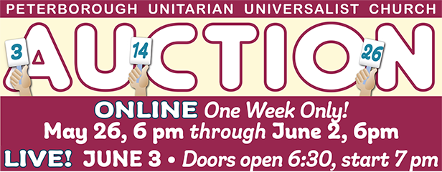
Donation Form: Offer an Item for bid

This form is due by May 19 at the latest.

Name
Address
Phone
Email
Donation
Value
Minimum Bid (typically 50% of value, if known)

Return ASAP to Rhonda Barkley rhondabarkley1@icloud.com

Items is a broad category, from baked goods to artwork, house & yard stuff, unique clothing, personal accessories…you get the idea. Really, anything that can be held.

Donation Guidelines: Choose your minimum bid carefully such that should that amount win the item, you would feel good about it. Please arrange with the Chair to have the item at the Church Office prior to the Auction. For sizable items, pickup can be arranged.

