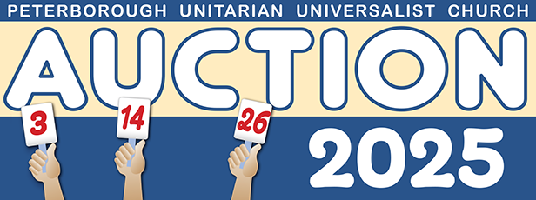

**ONLINE May 2-9, one week only.   
*LIVE!* SATURDAY, MAY 10, at 7:00 pm!**

Use this form to donate an **ITEM** to the **May 2025** PUUC Auction.

Name

Address

Phone E-mail

Donation: *Give us a detailed, generous description (unless it's a gift certificate) and a picture of your item.*

Location where service will be provided

Value

Minimum Bid (generally 50% of value)

***All donation forms need to be turned in by 4/26.***

Return ASAP to Rhonda Barkley **rhondabarkley1@icloud.com**

**Donation Guidelines**: Choose your minimum bid carefully. You should feel good about that amount if it is the final bid for your donation. Please arrange with Rhonda to have the item at the Church prior to the Auction. Pickup can be arranged for large items.